NATIONAL INSTITUTE OF TECHNOLOGY KARNATAKA SURATHKAL

DEPARTMENT OF INFORMATION TECHNOLOGY

**IT 301 Parallel Computing LAB 4**

02nd September 2020

Faculty: Dr. Geetha V and Mrs. Tanmayee

-------------------------------------------------------------------------------------------------------------------------------

**Name**: Chinmayi C. Ramakrishna

**Roll No**.: 181IT113

**Program 1**

**Execute following code and observe the working of task directive.**

**Check the result by removing if () clause with task.**

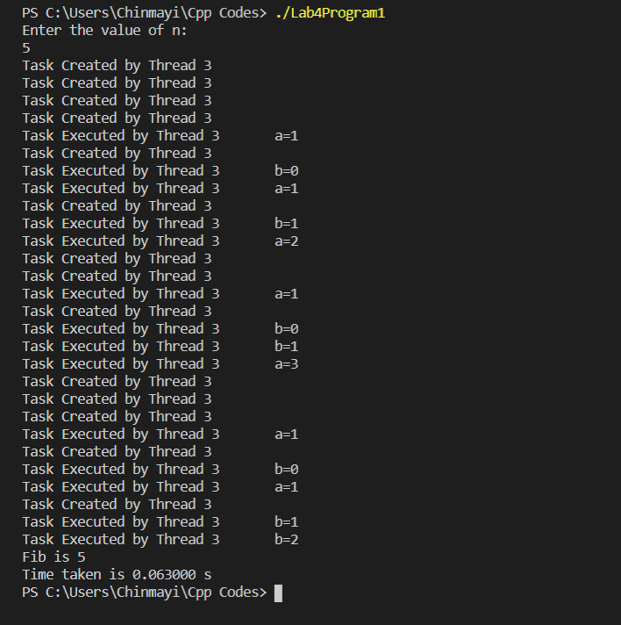

Parallel execution with if () clause. Thread 3 generates an undeferred task and the task region isn’t resumed till the generated undeferred task completion.

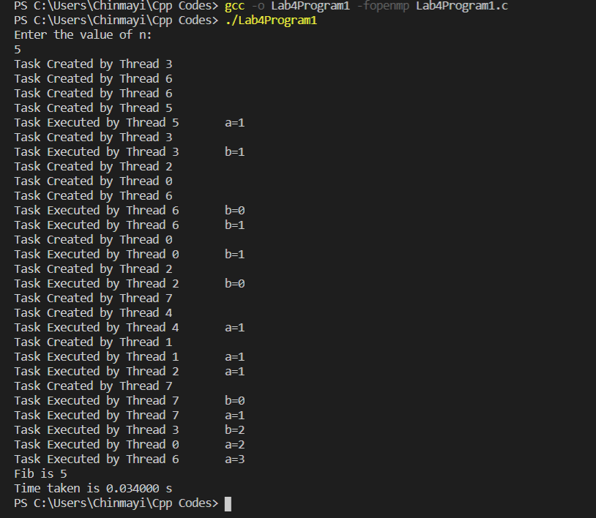

Parallel execution without if () clause. Thread 3 may immediately execute the task, or defer its execution. In the latter case, any thread in the team may be assigned the task. Here thread 5 is assigned the task.

**Program 2:**

**Write a C/C++ OpenMP program to find ROWSUM and COLUMNSUM of a matrix a[n][n].** **Compare the time of parallel execution with sequential execution.**

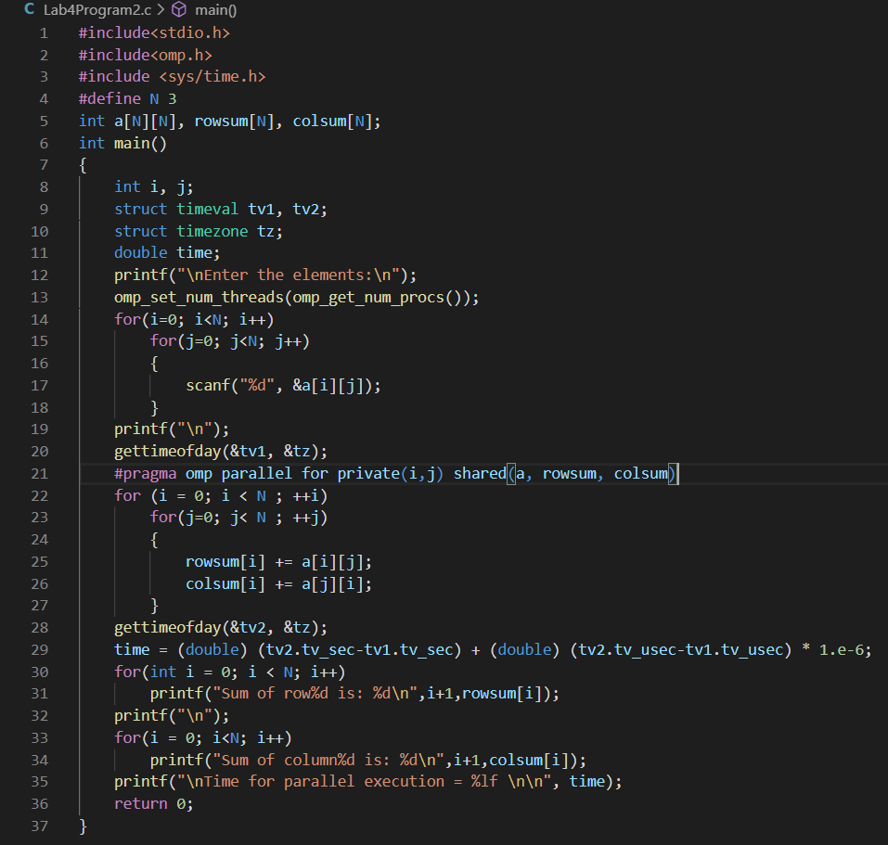

**Output:**

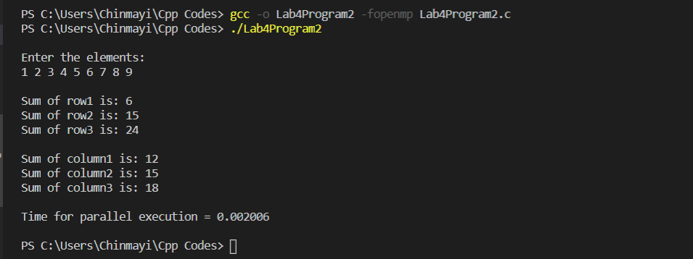

Without collapse().

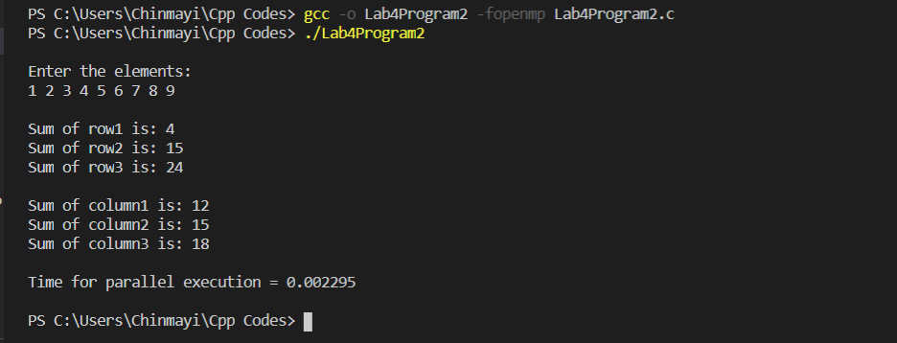

Using collapse(2)

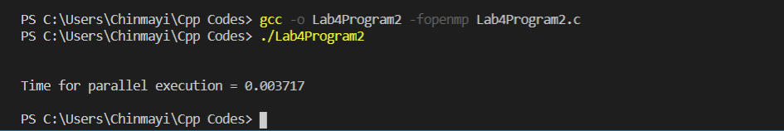

Array size = 1000

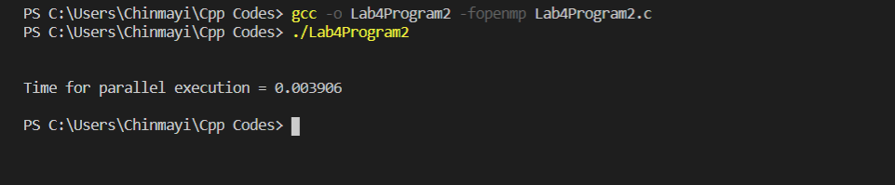

Array size = 1000 and collapse (2)

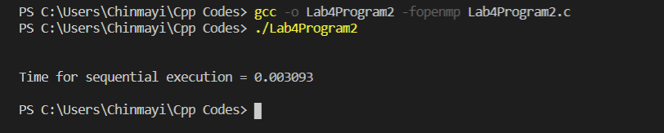

Array size = 1000 and sequential.

**Program 3:**

**Write a C/C++ OpenMP program to perform matrix multiplication. Compare the time of parallel execution with sequential execution.**

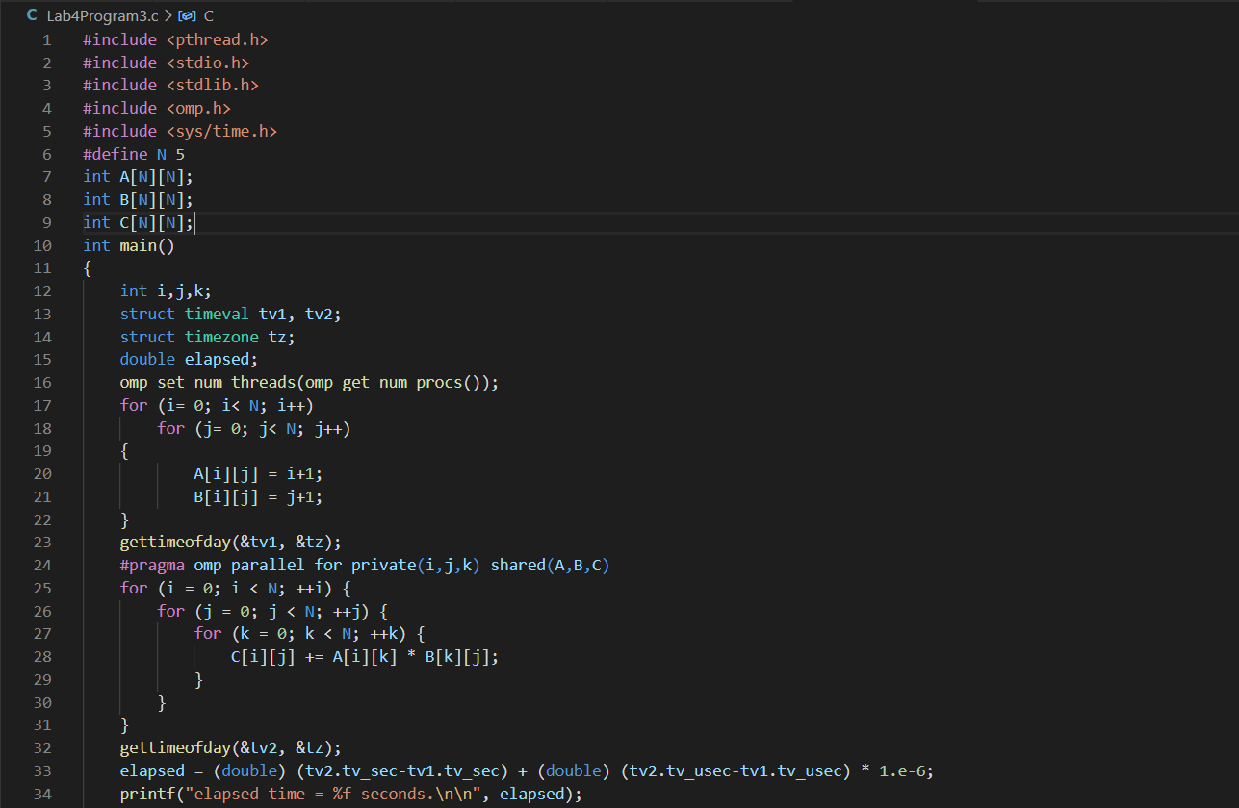

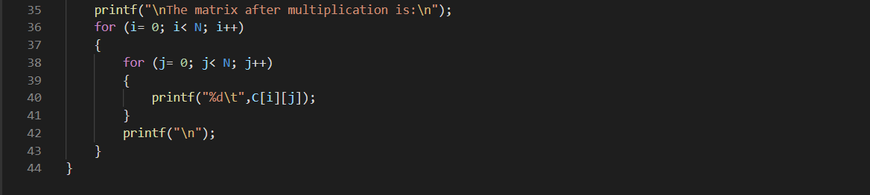

**Code for matrix multiplication using parallel execution.**

**Output:**

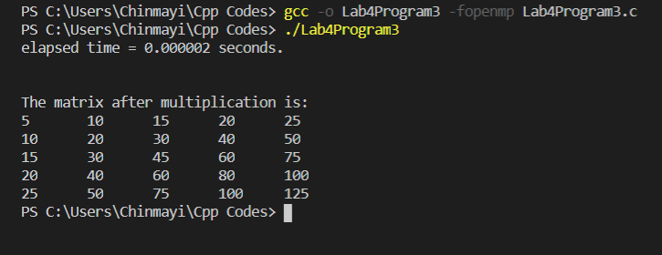

Matrix Multiplication using sequential execution.

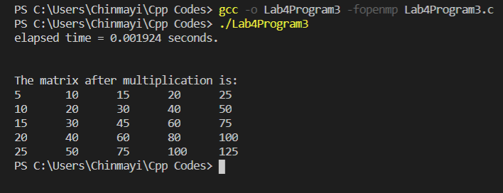

Matrix Multiplication using parallel execution.

Sequential takes lesser time for smaller inputs.